**The Scream**

*By Steve Brookman*

For the night is dark and full of terrors. — George R. R. Martin

“Don’t you ever do that to me again!” was the scream from my crew, the swinging boom and slatting sail had roused him from his seasick-induced slumber. He had scrambled from the berth below and seeing no one at the helm, just the blackness of that night and the howling wind, he panicked. We were ferrying *Oriana*, my 26’ cutter, from Portland, Maine to Boston, and just off the Isles of Shoals the increasing winds necessitated reducing sail.

The purpose of this trip was to get Oriana south for the season and also to give Davis, my crew, some boating experience as he had none and was considering getting into boating.

*Oriana* was launched in Noank, Connecticut, the previous year. My brother, who was living on Peaks Island, sailed with me to Maine where we spent the all-too-short summer exploring the coast— when fog and wind permitted. I had to take Oriana back south at the end of August so she could be shown at a September boatshow.

This was early in my aviation career and I was flying as a copilot on a Boeing 747. My usual route was to take off from Newark, New Jersey, late in the afternoon, fly the “red eye” across the Atlantic, and land in London in time for their breakfast. Then 24 hours later, I would fly back to Newark, hop a flight to Portland, take a taxi downtown, ride the ferry to Peaks Island, hike to my brother’s house, get out of my uniform, find my dingy hauled up on the rocky shore and row out to *Oriana* on her mooring, and then finally collapse in the cockpit. A couple of days later, I’d repeat the process—the glamorous life of an international pilot.

While riding the crew bus after one trip, I ran into Davis, a 747 captain with whom I had flown recently. We had discussed sailing during our flight and he had asked if he could join me to see if boating was something he’d want to pursue. was heading to Portland that weekend to ferry Oriana to Boston and invited him to join me. I told him that it would be a quick trip as I had to attend my captain’s upgrade class in Newark on Monday morning.

I picked him along with some supplies at 0800 the next Friday at Portland’s commercial waterfront. By 1000 hours the Portland’s skyline faded away as we made fair progress reaching with light southeasterly winds. Soon the rocking motion of the boat sent Davis down to the quarter berth with a queasy stomach. He’d pop up once and awhile but by 2000 hours the winds had picked up ahead of an approaching front, and that sent him below and kept him there. I reduced sail before he retired, changed out the drifter for the Yankee jib, and prepared for a long solo night watch.

By 0200 Saturday morning we were abeam the Isle of Shoals, with winds now gusting over 25 knots and I needed to take down the Yankee and tuck a reef in the main. I did not have an autopilot and used a tiller comb to help with steerage. Once the sail trim changed *Oriana* began veering back and forth, and into the wind. While I was up in the bow (harness on!) the mainsail made a racket slatting this way and that. That woke up Davis. He charged out of the cabin; seeing an empty cockpit he quickly spun around and spied me in the darkness, wrestling the Yankee. That’s when he screamed. I reminded him I was the captain and responsible for his safety and that of the boat. He eventually calmed down, but I’m not sure if he ever let himself fall back to sleep.

That woke Davis up! He charged o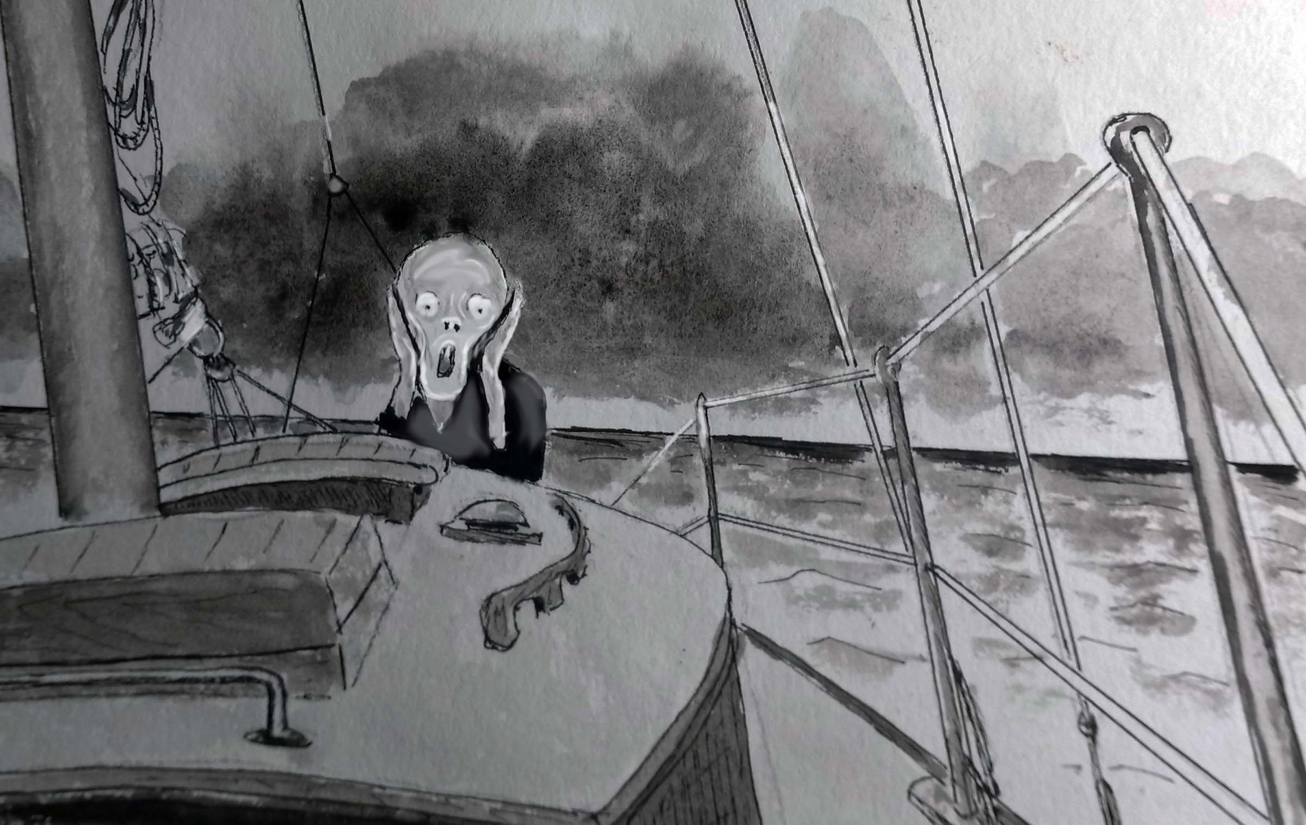ut of the cabin and when he saw the empty cockpit he quickly spun around with the widest eyes imaginable and spied me in the darkness, wrestling the Yankee. That’s when he screamed, and I had to remind him that I was the captain now and responsible for his safety and that of the boat. He eventually calmed down, but I’m not sure if he ever let himself fall back to sleep.

As we made our way closer to Boston, the winds increased, well above forecast, hitting the 35 knot range as we rounded Cape Ann at 0800 and increasing to 40 knots right on the nose as we gradually made our way to the final course into Boston harbor. The only way to make progress was to motor sail. My single cylinder Yanmar thumped away, but we could have walked faster. It was a brilliant, cloudless day, waves flattened by the stiff breeze and the constant spray of foam and spindrift encrusted our sunglasses. Because we were hard pressed with the rail down the head could not be pumped on that tack, adding to “joy” of this trip.

We had both flown this approach to Logan Airport many times, and now watched the jets overhead, covering the distance in a few minutes, not the 10 hours of beating that we endured. We eventually arrived in the harbor, many hours later than planned. Hewitt’s Cove Marina answered my hail and provided us with a berth. After a well-deserved dinner at a nearby restaurant and a sound, and quiet, night’s sleep, we snagged an early ferry to Logan, and caught a flight to Newark. It was a heck of a commute, but I was only a few minutes late for my captain’s class.

